CODE SCREENSHOT:-
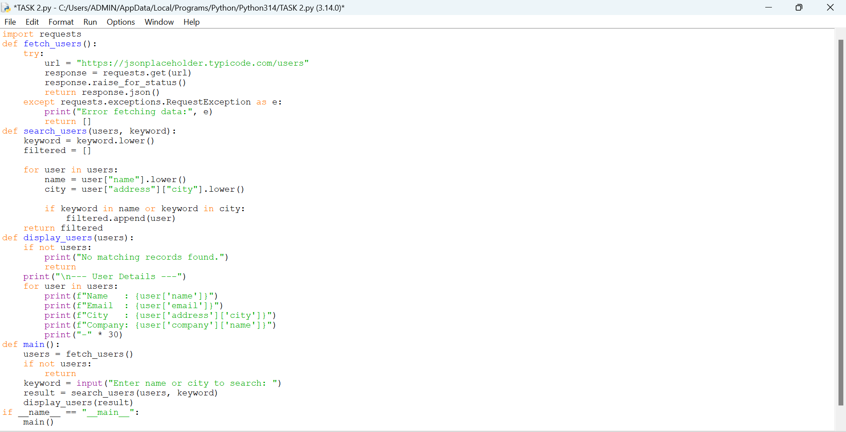

OUTPUT SCREENSHOT:-
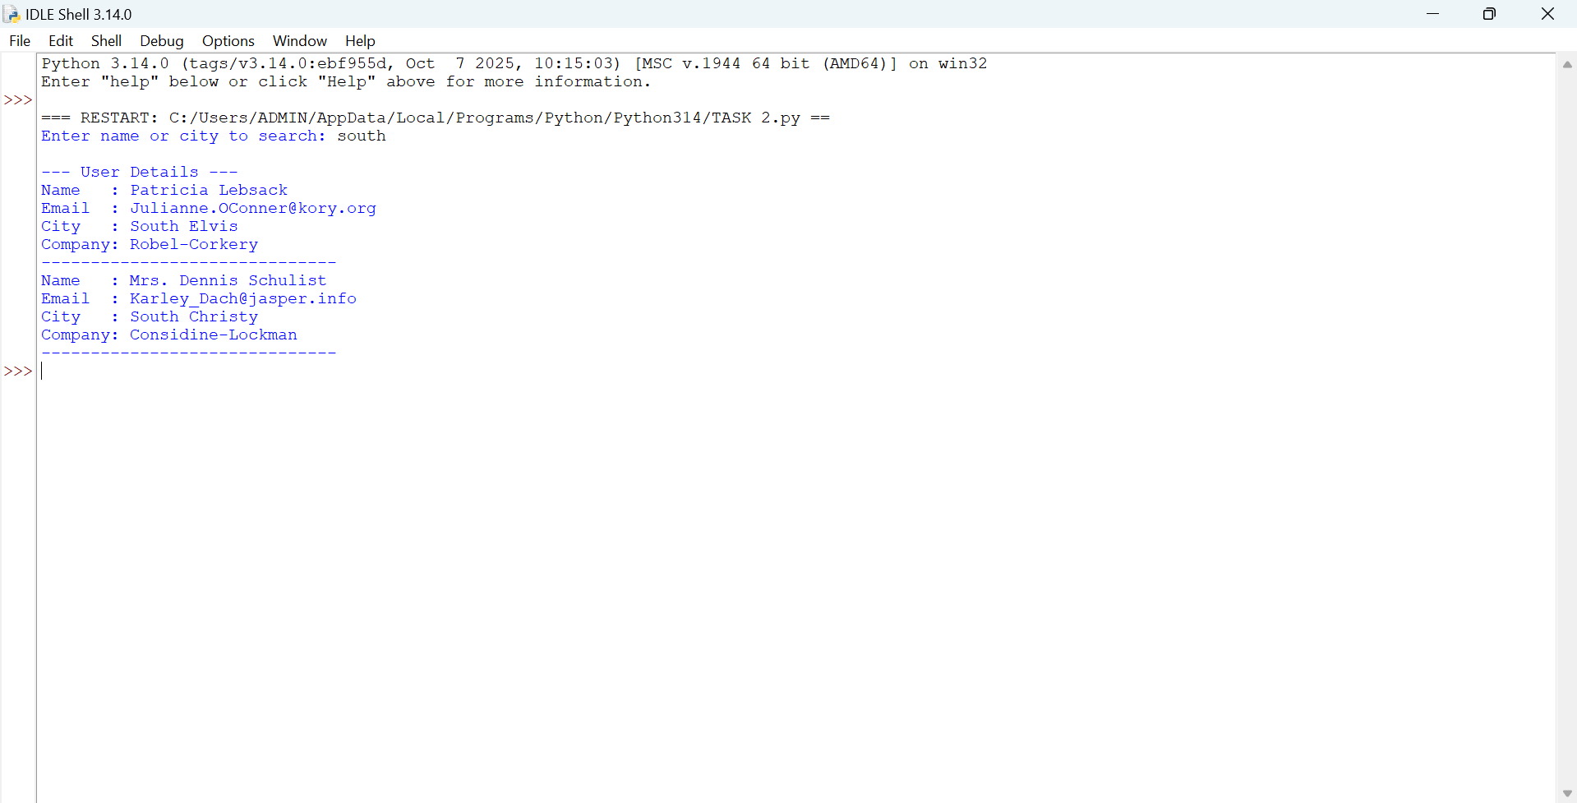

PYTHON SCRIPT:-
import requests
def fetch_users():
try:
url = "https://jsonplaceholder.typicode.com/users"
response = requests.get(url)
response.raise_for_status()
return response.json()
except requests.exceptions.RequestException as e:
print("Error fetching data:", e)
return []
def search_users(users, keyword):
keyword = keyword.lower()
filtered = []
for user in users:
name = user["name"].lower()
city = user["address"]["city"].lower()
if keyword in name or keyword in city:
filtered.append(user)
return filtered
def display_users(users):
if not users:
print("No matching records found.")
return
print("\n--- User Details ---")
for user in users:
print(f"Name : {user['name']}")
print(f"Email : {user['email']}")
print(f"City : {user['address']['city']}")
print(f"Company: {user['company']['name']}")
print("-" * 30)

def main():
users = fetch_users()

if not users:
return

keyword = input("Enter name or city to search: ")
result = search_users(users, keyword)
display_users(result)

if __name__ == "__main__":
main()

GITHUB LINK:-
https://github.com/R-KALAI-AMUDHAN/API-Integration-Weather-Crypto-News-.git

